# Airport Survey Data Report

## Overview:

I take airport survey dataset from <https://www.mavenanalytics.io/>. They gave some questions with dataset that must found via analysis.

Recommended Analysis Questions:

* Which percentage of airline passengers are satisfied? Does it vary by customer type? What about type of travel?
* What is the customer profile for a repeating airline passenger?
* Does flight distance affect customer preferences or flight patterns?
* Which factors contribute to customer satisfaction the most? What about dissatisfaction?

## Tool:

Python language

## Question 1:

## **Which percentage of airline passengers are satisfied? Does it vary by customer type? What about type of travel?**

The percentage of Satisfied Passenger: 43.44%

The percentage of Neutral or Dissatisfied Passenger: 56.55%

**Found:** Neutral or Dissatisfied Passenger percentage higher than Satisfied Passenger

Satisfaction percentage by customer type:

First-time 23.96%

Returning 47.81%

**Found:**  If we say does it vary by customer type then it is not wrong as we can see returning satisfied passenger percentage is higher.

Satisfaction percentage by travel type:

Business 58.37%

Personal 10.13%

**Found**: As we can see business travel type percentage is higher, it’s varied by travel type too.

## Question 2:

**What is the customer profile for a repeating airline passenger?**

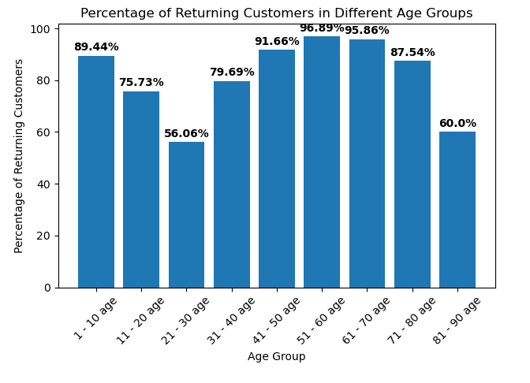

It’s a bar chart of the age group of people that shows the percentage of returning customers.

## Question 3:

**Does flight distance affect customer preferences or flight patterns?**

**Found:** 'Flight Distance' has a negative correlation of with 'Departure and Arrival Time Convenience,’ and ‘Arrival Delay’ which means that as the flight distance increases, the satisfaction with departure and arrival time convenience tends to decrease slightly.

## Question 4:

**Which factors contribute to customer satisfaction the most? What about dissatisfaction?**

The factor that contributes to customer satisfaction the most is online boarding (4.03/5).

The factor that contributes to customer dissatisfaction the most is In-flight Wi-Fi Service (2.4/5).